A000-**Indo-Sulawesi-Toraja Grave Guardian-Tau Tau-**Nangka **Wood-early 20th c**

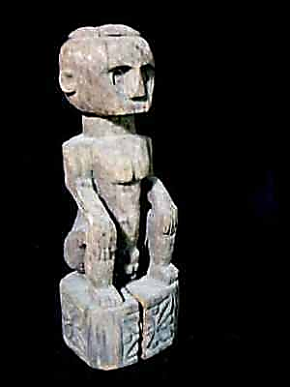 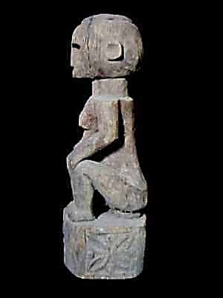 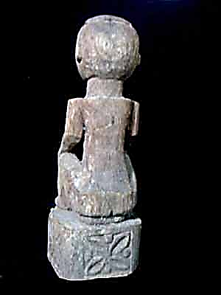 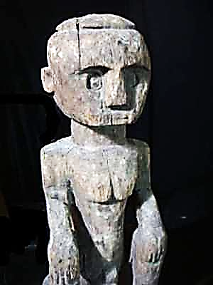

**Figs. 1-4. Indonesia-Sulawesi-Toraja Grave Guardian-Tau Tau-Wood-early 20th c**

**Case no.:**

**Accession Number:**

**Formal Label: Indonesia-Sulawesi-Toraja Grave Guardian-Tau Tau-Wood-early 20th c**

**Display Description:**

**Tau-tau (“little person effigies”)**  
  
The word *tau-tau* means 'little person', which is an image of the deceased. Today they are dressed in clothing, complete with accessories and jewelry*.* The effigy is more than a memorial statue as we know it, for it is thought to have a soul, the soul of the deceased.

The *tau-tau* are clothed exactly like a Toraja of status - in an early phase of the ritual, in simple garments, but in grand apparel when he is carried to the slaughtering place of the *kerbau.*Finally the *tau-tau,* approximately one and a half meters tall, are set up beside the rock grave. As they represent the deceased, offerings are made to them. This explains Protestant opposition to the inclusion of the dolls in the burial ceremony. At the funeral of Lai' Kalua' (end 1930's), however, a *tau-tau* was part of the procession in spite of the fact that, before she died, she had converted to Christianity. For the burial of a woman of prominent descent, which took place in Kesu' in 1975, a *tau-tau* was also created. The effigy prompted protests from several family members and from the deceased's church, the Protestant Gereja Toraja. In 1978, however, an effigy was carried in the cortege of a Christian funeral.  
  
*Manufacture of a tau-tau*A specialist *(pande tau-tau)* fashions the effigy out of *nangka-wood.* Certain individuals have won fame in the making of these dolls; the carving supplies them with supplementary income. Well-known *pande* are Teken in Kesu' and Pong Salapu in Sangalla'. Today, resemblance to the deceased is the specialist's goal but one it was to present the person’s soul to the resting place in the high mausoleum in the rocks.. Nowadays, since some *tau-tau* craftsmen, Teken, or Olle, have had training in sculpture on Bali, increasing verisimilitude is being achieved but, it seems to me, at the cost of something of the fascination and mystery characteristic of early death dolls.  
  
Manufacture of the *tau-tau* is accompanied by offerings. *Tau-tau* have the genitals of whichever sex which they represent. The dolls have movable limbs so that, for example, even the forearm and upperarm can be detached from each other. The head, too, can be removed. Old effigies found in the vicinity of ancient coffins, do not have movable limbs.  
  
  
*Function of the tau-tau*

The *tau-tau* is fashioned before the second phase of a major mortuary ritual for the dead commences. During the manufacture of the doll, the woodcarver sleeps near (or even under) the house where the deceased lies on view. Actual work on the effigy also takes place in the vicinity of his house, possibly even on the floor of the rice barn opposite the *tongkonan.* When the image is completed it is placed beside the dead. Just like the deceased, the *tau-tau* receives food to eat (an offering, indeed, for giving food to the *tau-tau* is a ritual process). All this occurs before and during the second phase of the ritual, in other words for quite same time, as the time lapse between the first and the second phase of the ritual can be considerable. While the deceased is brought down to the floor of the rice barn to lie in state there, the *tau-tau* is also brought down and set in position before the barn. Before this the effigy stood in front of the *tulak somba* of the house. The doll then had on rather simple clothing, for a male *tau-tau* a pair of short white trousers *(seppa tallu buku).* The outfit remains unchanged when the *tau-tau* takes position in front of the rice barn. Only once the effigy together with the dead - and in the same manner - is carried in a palanquin to the slaughtering place of the buffaloes, does it acquire fancy dress. A headdress appropriate to the status of the deceased is set in place, expensive jewellery is hung round the doll's neck, and his body ornamented with sash and krisses. At the slaughtering place of the buffaloes, the *tau-tau* remains in the immediate vicinity of the corpse.  
The *tau-tau,* stationed before the grave (or on top of it) keeps alive the memory of the ancestor 'of old'. Once every so many years, his clothing is changed, usually before burial of a new person of rank takes place. From a great height, one by one, the effigies are carried down where they are carefully dressed anew, later to be carried aloft again to their posts in front of the grave. "That it Puang X", people cry out as a doll is carried down from the cliffs. "And that is Puang Y". Older people often recall exactly who the effigies (in Suaya more than a dozen in all) represent.  
That the effigy only plays a role shortly prior to the second phase of the mortuary ritual is probably a matter of the 'maturation' of the deceased. In the first phase of the death least, *aluk pia,* the 'child ritual', the deceased had not yet attained a state in which he can do anything for the rice and for his descendants. During the second stage of the death ritual, however, he already approaches that state. Then the *tau-tau,* the image of the deceased, the 'living dead', is stationed beside the corpse. In the course of the first phase of a death ritual for an extremely eminent personage, a temporary *tau-tau* is occasionally fashioned from a bamboo rod. Decked with clothes this effigy rather resembles a scarecrow. Such a temporary *tau-tau* is called *bate lepong.*

*Source: THE SA'DAN TORAJA by HETTY NOOY-PALM*

**LC Classification:** DS632.T7.A1

**Date or Time Horizon:** **early 20th c**

**Geographical Area:** **Sulawesi, Toraja**

**Map:**

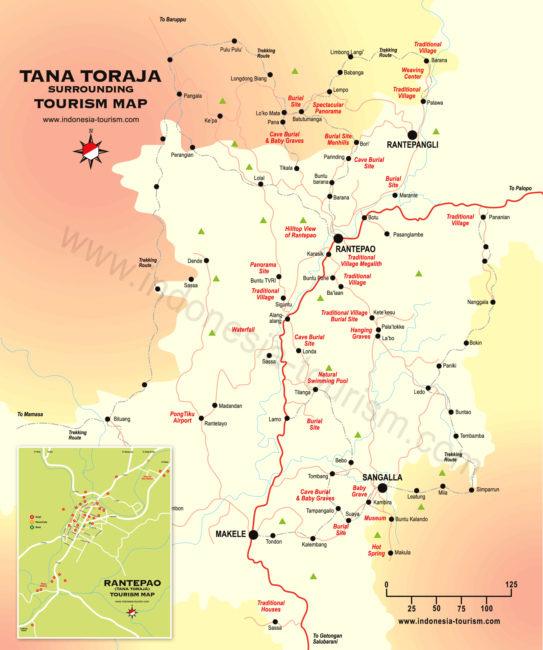

**https://web.archive.org/web/20091028230456if_/http://www.indonesia-tourism.com/south-sulawesi/map/tana-toraja-map.png**

**GPS coordinates:**

**Cultural Affiliation:** Sa’dan Toraja

**Medium:** wood, patina of the figure is brownish-gray

**Dimensions:** H 30 in / 72 cm

**Weight:**

**Condition:**

**Provenance:** Toraja, Sulawesi, Indonesia

**Discussion:**

**Torajans live in South Sulawesi (Formerly the Celebes). Their name “Toraja” comes from a** Buginese term *to riaja*, meaning "people of the uplands," because the people built their homes on high hills for protection. Prior to 1960 Torajans lived in an isolated, agrarian world—in which social life and religious customs were outgrowths of the *Aluk To Dolo* or “rituals of the old ones.” The *to minaa* priest recites the origin of the Toraja, of how the cosmos and the gods came into being how the *to manurum*, the first nobleman, descended from heaven bringing with him food plants and animals, a heavenly house and slaves and the complete hierarchical social order including the priests: the to buraka, who is the highest religious functionary, the rice priest, the medicine priest and the death priest. However, Torajans also believe that they originally came from Cambodia, arriving in a storm from the northern seas on battered boats as and today their houses are all shaped like these first boats.

Until the coming of missionaries in the nineteenth century the Torajans lived in almost complete isolation, as one of the fiercest and most remote people in Indonesia. When in 1905-6 the Dutch gained control over the Torajan mountains they moved the people from their fortified mountain homes into the valleys as agriculture was expanded, and taxes, Christianity and Dutch were introduced. Before the people knew only an oral tradition. Fertility rituals were stopped, as was the practice of offering freshly severed human heads at the end of a funeral. Buffalo were substituted for the human heads and these are raised on a large scale for ritual purposes, as a major death feast needs a sacrifice of about a hundred buffalo.  
Despite Christianity, there is still very strong *ada*t, village ritual. But rituals can be mixed in with Christian ritual as in The Feast of the Dead people attend church and afterwards sacrifice their substitute for human heads, water buffalo.

**References:**

Budiman, Michaela. 2013. *Exploring the Funeral Traditions of Southeast Asia-Contemporary Funeral Rituals of Sa'dan Toraja: From Aluk Todolo to “New” Religions*. Prague: Karolinum Press.

Nooy-Palm, H., 2014. *The Sa’dan-Toraja: A study of their social life and religion*. Springer.